**IEnumerable Interface – (Extension) members**

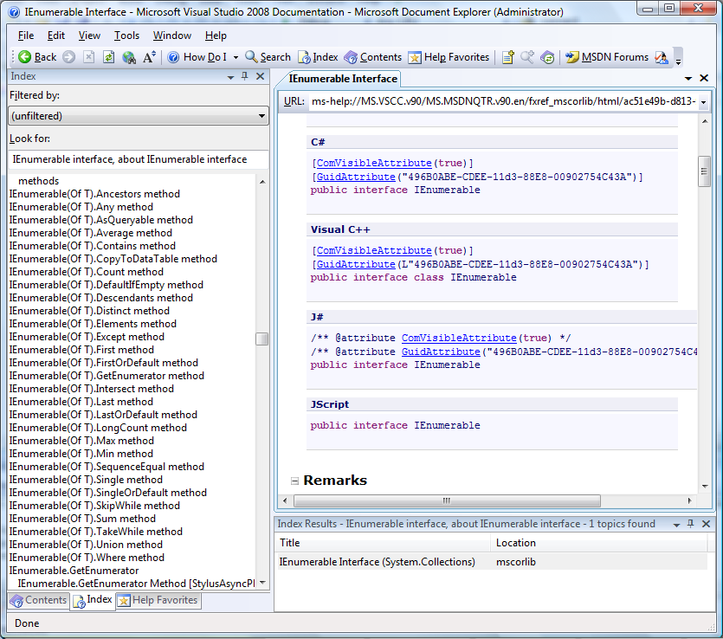

IQueryable Interface (Extension Methods)

